Lab 07 – Worksheet

Name: Mohammad Husain Naqvi  Syed Fakhar Iqbal Rizvi | ID: 11062  11091 | Section: T-4

Note: Assumptions and logics should be explained separately in tasks after the task results.

Task 1
Block Diagrams
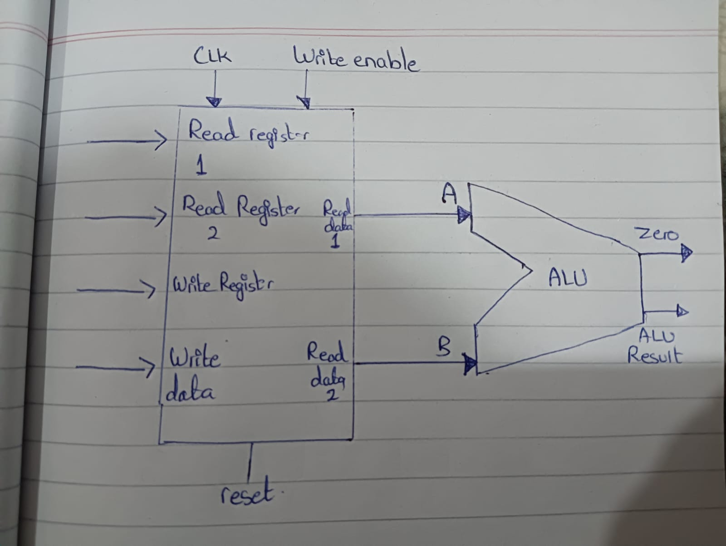

Comments

Task 2

Modules + Testbench:
Register File:

`timescale 1ns / 1ps
module RegisterFile(
input wire clk,
input wire rst,
input wire WriteEnable,
input wire [4:0] rs1,
input wire [4:0] rs2,
input wire [4:0] rd,
input wire [31:0] WriteData,
output reg [31:0] ReadData1,
output reg [31:0] ReadData2
);
reg [31:0] regs [31:0];
integer i;
initial begin
for (i = 0; i < 32; i = i + 1) begin
regs[i] = i;
end
end
always @(*) begin
ReadData1 = regs[rs1];
ReadData2 = regs[rs2];
end
always @(posedge clk or posedge rst) begin
if (rst) begin
for (i = 0; i < 32; i = i + 1) begin
regs[i] <= i;
end
end else if (WriteEnable && (rd != 5'b00000)) begin
regs[rd] <= WriteData;
end
end

endmodule
Top ALU_RegisterFile Module:

`timescale 1ns / 1ps
module top_rf_alu(
input wire clk,
input wire btnC, // Reset button
input wire [15:0] sw, // Switches
output wire [15:0] led, // LEDs
output wire [6:0] seg, // Seven segment display
output wire [3:0] an // Seven segment anode
);
wire rst_db;
debouncer db_rst (
.clk(clk),
.pbin(btnC),
.pbout(rst_db)
);
wire [31:0] sw_readData;
wire [15:0] sw_led_mirror;
switches sw_if (
.clk(clk),
.rst(rst_db),
.writeData(32'b0),
.writeEnable(1'b0),
.readEnable(1'b1), //we always read the switches
.memAddress(30'b0),
.sw(sw),
.readData(sw_readData),
.leds(sw_led_mirror)
);

// Switch 0 controls writing to the register file
wire WriteEnable = sw_readData[0];

// sw[4:1] (4 bits) selects the second source register rs2 (x0 to x15)
wire [4:0] rs2 = {1'b0, sw_readData[4:1]};

// sw[9:5] (5 bits) selects the first source register rs1 (x0 to x31)
wire [4:0] rs1 = sw_readData[9:5];

// sw[10] can be left as an extra bit or used for write data
wire [31:0] WriteData = {31'b0, sw_readData[10]};

// sw[14:11] (4 bits) selects the ALU operation
wire [3:0] ALUControl = sw_readData[14:11];

// Target register rd can match rs2 (or keep as 5'd2)
wire [4:0] rd = rs2; //rd=x2
wire [31:0] ReadData1; //output 1
wire [31:0] ReadData2; //output 2
wire [31:0] alu_result;
wire alu_zero;
//Register File
RegisterFile rf (
.clk(clk),
.rst(rst_db),
.WriteEnable(WriteEnable),
.rs1(rs1),
.rs2(rs2),
.rd(rd),
.WriteData(WriteData),
.ReadData1(ReadData1),
.ReadData2(ReadData2)
);
// ALU FILE
ALU_32bit alu (
.A(ReadData1),
.B(ReadData2),
.ALUControl(ALUControl),
.Result(alu_result),
.Zero(alu_zero)
);
assign led[14:0] = alu_result[14:0];
assign led[15] = alu_zero;

leds led_if (
.clk(clk),
.rst(rst_db),
.btns(16'b0),
.writeData(alu_result),
.writeEnable(1'b0),
.readEnable(1'b0),
.memAddress(30'b0),
.display_value(alu_result[3:0]),
.readData(),
.seg(seg), // Seven-segment display output
.an(an) // Seven-segment anode control
);

endmodule

Debouncer:
`timescale 1ns / 1ps
//////////////////////////////////////////////////////////////////////////////////
// Company:
// Engineer:
//
// Create Date: 14.10.2026 11:04:22
// Design Name:
// Module Name: debouncer
// Project Name:
// Target Devices:
// Tool Versions:
// Description:
//
// Dependencies:
//
// Revision:
// Revision 0.01 - File Created
// Additional Comments:
//
//////////////////////////////////////////////////////////////////////////////////

`timescale 1ns / 1ps

module debouncer (
input wire clk,
input wire pbin,
output reg pbout
);

// 16-bit counter creates ~0.65ms debounce window at 100MHz clock
reg [15:0] counter = 16'd0;
reg state = 1'b0;

always @(posedge clk) begin
if (pbin != state) begin
counter <= counter + 1'b1;
if (counter == 16'hFFFF) begin
state <= pbin;
counter <= 16'd0;
end
end else begin
counter <= 16'd0;
end
pbout <= state;
end

endmodule
Swtiches:
`timescale 1ns / 1ps
//////////////////////////////////////////////////////////////////////////////////
// Company:
// Engineer:
//
// Create Date: 14.10.2026 11:04:22
// Design Name:
// Module Name: debouncer
// Project Name:
// Target Devices:
// Tool Versions:
// Description:
//
// Dependencies:
//
// Revision:
// Revision 0.01 - File Created
// Additional Comments:
//
//////////////////////////////////////////////////////////////////////////////////

`timescale 1ns / 1ps

module debouncer (
input wire clk,
input wire pbin,
output reg pbout
);

// 16-bit counter creates ~0.65ms debounce window at 100MHz clock
reg [15:0] counter = 16'd0;
reg state = 1'b0;

always @(posedge clk) begin
if (pbin != state) begin
counter <= counter + 1'b1;
if (counter == 16'hFFFF) begin
state <= pbin;
counter <= 16'd0;
end
end else begin
counter <= 16'd0;
end
pbout <= state;
end

endmodule
Alu_32bit:
`timescale 1ns / 1ps
//////////////////////////////////////////////////////////////////////////////////
// Company:
// Engineer:
//
// Create Date: 14.10.2026 11:05:30
// Design Name:
// Module Name: Alu_32bit
// Project Name:
// Target Devices:
// Tool Versions:
// Description:
//
// Dependencies:
//
// Revision:
// Revision 0.01 - File Created
// Additional Comments:
//
//////////////////////////////////////////////////////////////////////////////////

`timescale 1ns / 1ps

module ALU_32bit(
input wire [31:0] A,
input wire [31:0] B,
input wire [3:0] ALUControl,
output reg [31:0] Result,
output wire Zero
);

always @(*) begin
case (ALUControl)
4'b0010: Result = A + B; // ADD 2 + 5 = 7
4'b0110: Result = A - B; // SUB 2-5= 3 (unsigned)
4'b0000: Result = A & B; // AND 00101 & 0010 = 0
4'b0001: Result = A | B; // OR (1)
4'b1100: Result = A ^ B; // XOR (12)
4'b0100: Result = A << B[4:0]; // SLL (4)
4'b0101: Result = A >> B[4:0]; // SRL (5)
default: Result = 32'd0;
endcase
end

// Zero flag is high when Result is exactly 0
assign Zero = (Result == 32'd0);

endmodule

LED:

`timescale 1ns / 1ps
//////////////////////////////////////////////////////////////////////////////////
// Company:
// Engineer:
//
// Create Date: 14.10.2026 11:05:30
// Design Name:
// Module Name: Alu_32bit
// Project Name:
// Target Devices:
// Tool Versions:
// Description:
//
// Dependencies:
//
// Revision:
// Revision 0.01 - File Created
// Additional Comments:
//
//////////////////////////////////////////////////////////////////////////////////

`timescale 1ns / 1ps

module ALU_32bit(
input wire [31:0] A,
input wire [31:0] B,
input wire [3:0] ALUControl,
output reg [31:0] Result,
output wire Zero
);

always @(*) begin
case (ALUControl)
4'b0010: Result = A + B; // ADD 2 + 5 = 7
4'b0110: Result = A - B; // SUB 2-5= 3 (unsigned)
4'b0000: Result = A & B; // AND 00101 & 0010 = 0
4'b0001: Result = A | B; // OR (1)
4'b1100: Result = A ^ B; // XOR (12)
4'b0100: Result = A << B[4:0]; // SLL (4)
4'b0101: Result = A >> B[4:0]; // SRL (5)
default: Result = 32'd0;
endcase
end

// Zero flag is high when Result is exactly 0
assign Zero = (Result == 32'd0);

endmodule

TESTBENCH:
tb_top_rf_alu:

`timescale 1ns / 1ps
//////////////////////////////////////////////////////////////////////////////////
// Company:
// Engineer:
//
// Create Date: 14.10.2026 11:13:37
// Design Name:
// Module Name: Top_Alu_Rf_tb
// Project Name:
// Target Devices:
// Tool Versions:
// Description:
//
// Dependencies:
//
// Revision:
// Revision 0.01 - File Created
// Additional Comments:
//
//////////////////////////////////////////////////////////////////////////////////

`timescale 1ns/1ps

module tb_top_rf_alu;
reg clk;
reg rst;
reg WriteEnable;
reg [4:0] rs1, rs2, rd;
reg [31:0] WriteData;
wire [31:0] ReadData1, ReadData2;
reg [3:0] ALUControl;
wire [31:0] ALUResult;
wire Zero;

RegisterFile rf (
.clk(clk),
.rst(rst),
.WriteEnable(WriteEnable),
.rs1(rs1),
.rs2(rs2),
.rd(rd),
.WriteData(WriteData),
.ReadData1(ReadData1),
.ReadData2(ReadData2)
);

ALU_32bit alu (
.A(ReadData1),
.B(ReadData2),
.ALUControl(ALUControl),
.Result(ALUResult),
.Zero(Zero)
);

// Clock generator: 100MHz (10ns period)
initial begin
clk = 0;
forever #5 clk = ~clk;
end

localparam IDLE = 3'd0;
localparam WRITE_REGS = 3'd1;
localparam READ_REGISTERS = 3'd2;
localparam ALU_OPERATION = 3'd3;
localparam WRITE_REGISTERS = 3'd4;

reg [2:0] state;
reg [1:0] init_idx;
reg [3:0] op;
reg [4:0] dest;

initial begin
rst = 1;
@(posedge clk);
@(posedge clk);
rst = 0;
repeat (120) @(posedge clk);
$finish;
end

always @(posedge clk or posedge rst) begin
if (rst) begin
state <= IDLE;
WriteEnable <= 0;
rs1 <= 0; rs2 <= 0; rd <= 0;
WriteData <= 0;
ALUControl <= 4'b0010;
init_idx <= 0;
op <= 0;
dest <= 0;
end else begin
case (state)
IDLE: begin
WriteEnable <= 0;
init_idx <= 0;
op <= 0;
state <= WRITE_REGS;
end

WRITE_REGS: begin
WriteEnable <= 1;
case (init_idx)
2'd0: begin
rd <= 5'd1;
WriteData <= 32'h1010_1010;
init_idx <= 1;
end
2'd1: begin
rd <= 5'd2;
WriteData <= 32'h0101_0101;
init_idx <= 2;
end
2'd2: begin
rd <= 5'd3;
WriteData <= 32'h0000_0005;
init_idx <= 0;
WriteEnable <= 0;
state <= READ_REGISTERS;
end
endcase
end

READ_REGISTERS: begin
WriteEnable <= 0;
rs1 <= 5'd1;
rs2 <= 5'd2;
case (op)
4'd0: begin ALUControl <= 4'b0010; dest <= 5'd4; end // ADD
4'd1: begin ALUControl <= 4'b0110; dest <= 5'd5; end // SUB
4'd2: begin ALUControl <= 4'b0000; dest <= 5'd6; end // AND
4'd3: begin ALUControl <= 4'b0001; dest <= 5'd7; end // OR
4'd4: begin ALUControl <= 4'b1100; dest <= 5'd8; end // XOR
4'd5: begin ALUControl <= 4'b0100; dest <= 5'd9; end // SLL
4'd6: begin ALUControl <= 4'b0101; dest <= 5'd10; end // SRL
4'd7: begin
rs1 <= 5'd1;
rs2 <= 5'd1;
ALUControl <= 4'b0110; // x1 - x1 => 0
dest <= 5'd11;
end
4'd8: begin
ALUControl <= 4'b0010;
dest <= 5'd12;
end
4'd9: begin
rs1 <= 5'd12;
rs2 <= 5'd0;
ALUControl <= 4'b0010;
dest <= 5'd0; // Test write to x0 (should be discarded)
end
endcase
state <= ALU_OPERATION;
end

ALU_OPERATION: begin
state <= WRITE_REGISTERS;
end

WRITE_REGISTERS: begin
case (op)
4'd0, 4'd1, 4'd2, 4'd3, 4'd4, 4'd5, 4'd6: begin
rd <= dest;
WriteData <= ALUResult;
WriteEnable <= 1;
op <= op + 1;
state <= READ_REGISTERS;
end
4'd7: begin
rd <= dest; // x11
WriteData <= (Zero ? 32'd1 : 32'd0);
WriteEnable <= 1;
op <= 8;
state <= READ_REGISTERS;
end
4'd8: begin
rd <= 5'd12;
WriteData <= 32'hAAAA_5555;
WriteEnable <= 1;
op <= 9;
state <= READ_REGISTERS;
end
4'd9: begin
WriteEnable <= 0;
rs1 <= 5'd4; // read x4 at the end
rs2 <= 5'd5; // read x5 at the end
state <= IDLE;
end
endcase
end
endcase
end
end

endmodule

REGISTER TB:
`timescale 1ns / 1ps

module tb_RegisterFile;

// DUT Inputs
reg clk;
reg rst;
reg WriteEnable;
reg [4:0] rs1;
reg [4:0] rs2;
reg [4:0] rd;
reg [31:0] WriteData;

// DUT Outputs
wire [31:0] ReadData1;
wire [31:0] ReadData2;

// Error counter
integer errors = 0;

// Instantiate the Device Under Test (DUT)
RegisterFile dut (
.clk(clk),
.rst(rst),
.WriteEnable(WriteEnable),
.rs1(rs1),
.rs2(rs2),
.rd(rd),
.WriteData(WriteData),
.ReadData1(ReadData1),
.ReadData2(ReadData2)
);

// 100 MHz Clock Generation (10ns period)
initial begin
clk = 1'b0;
forever #5 clk = ~clk;
end

// Verification Task
task check_outputs(
input [4:0] r1_addr, input [31:0] exp1,
input [4:0] r2_addr, input [31:0] exp2,
input [8*30:1] test_name
);
begin
rs1 = r1_addr;
rs2 = r2_addr;
#1; // allow combinational read paths to settle
if (ReadData1 !== exp1) begin
$display("[FAIL] %0s | ReadData1 (reg %0d) = 0x%08h, Expected = 0x%08h", test_name, r1_addr, ReadData1, exp1);
errors = errors + 1;
end else if (ReadData2 !== exp2) begin
$display("[FAIL] %0s | ReadData2 (reg %0d) = 0x%08h, Expected = 0x%08h", test_name, r2_addr, ReadData2, exp2);
errors = errors + 1;
end else begin
$display("[PASS] %0s | reg[%0d]=0x%08h, reg[%0d]=0x%08h", test_name, r1_addr, ReadData1, r2_addr, ReadData2);
end
end
endtask

// Main Test Sequence
initial begin
// 1. Initialize signals and assert Reset
rst = 1'b1;
WriteEnable = 1'b0;
rs1 = 5'd0;
rs2 = 5'd0;
rd = 5'd0;
WriteData = 32'd0;

#20;
@(posedge clk);
rst = 1'b0;
#1;

// Test 1: Verify Initial / Reset Values (regs[i] == i)
check_outputs(5'd0, 32'd0, 5'd5, 32'd5, "Reset Values (x0 & x5)");
check_outputs(5'd10, 32'd10, 5'd31, 32'd31, "Reset Values (x10 & x31)");

// Test 2: Standard Write to Register x5
@(negedge clk);
rd = 5'd5;
WriteData = 32'h1234_5678;
WriteEnable = 1'b1;

@(negedge clk);
WriteEnable = 1'b0; // Deassert write enable
check_outputs(5'd5, 32'h1234_5678, 5'd0, 32'd0, "Write to x5");

// Test 3: Attempt writing to Register x0 (Must remain 0)
@(negedge clk);
rd = 5'd0;
WriteData = 32'hDEAD_BEEF;
WriteEnable = 1'b1;

@(negedge clk);
WriteEnable = 1'b0;
check_outputs(5'd0, 32'h0000_0000, 5'd5, 32'h1234_5678, "Write to x0 Ignored");

// Test 4: Simultaneous dual-port read after writing to x6
@(negedge clk);
rd = 5'd6;
WriteData = 32'h0000_00AA;
WriteEnable = 1'b1;

@(negedge clk);
WriteEnable = 1'b0;
check_outputs(5'd5, 32'h1234_5678, 5'd6, 32'h0000_00AA, "Dual Read x5 & x6");

// Test 5: Overwrite existing value in x5
@(negedge clk);
rd = 5'd5;
WriteData = 32'h0000_0055;
WriteEnable = 1'b1;

@(negedge clk);
WriteEnable = 1'b0;
check_outputs(5'd5, 32'h0000_0055, 5'd6, 32'h0000_00AA, "Overwrite x5");

// Test 6: Verify Reset restores regs[i] = i
@(negedge clk);
rst = 1'b1;
@(posedge clk);
#1;
rst = 1'b0;
#1;
check_outputs(5'd5, 32'd5, 5'd6, 32'd6, "Reset Restores Defaults");

// Final Report
#20;
$display("----------------------------------------------");
if (errors == 0)
$display("ALL TESTS PASSED SUCCESSFULLY!");
else
$display("TEST FAILED WITH %0d ERRORS.", errors);
$display("----------------------------------------------");
$finish;
end

endmodule

Results:

Task 3

RTL Schematics

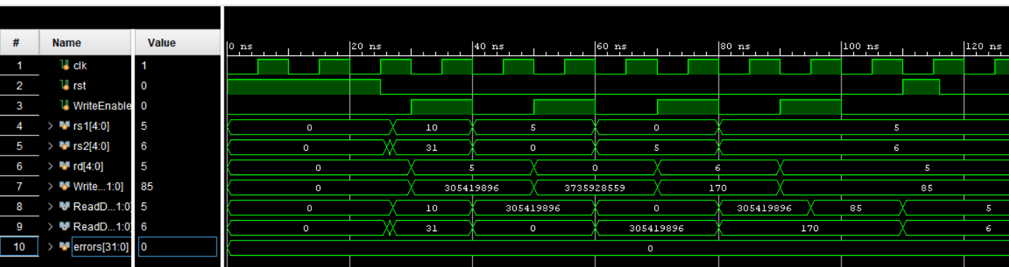

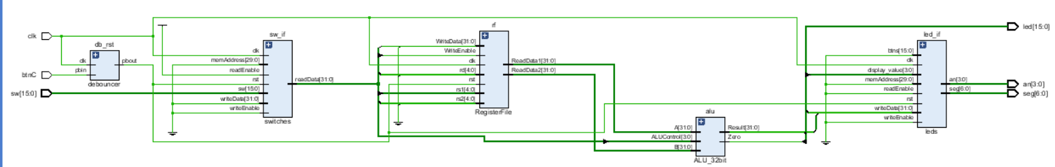

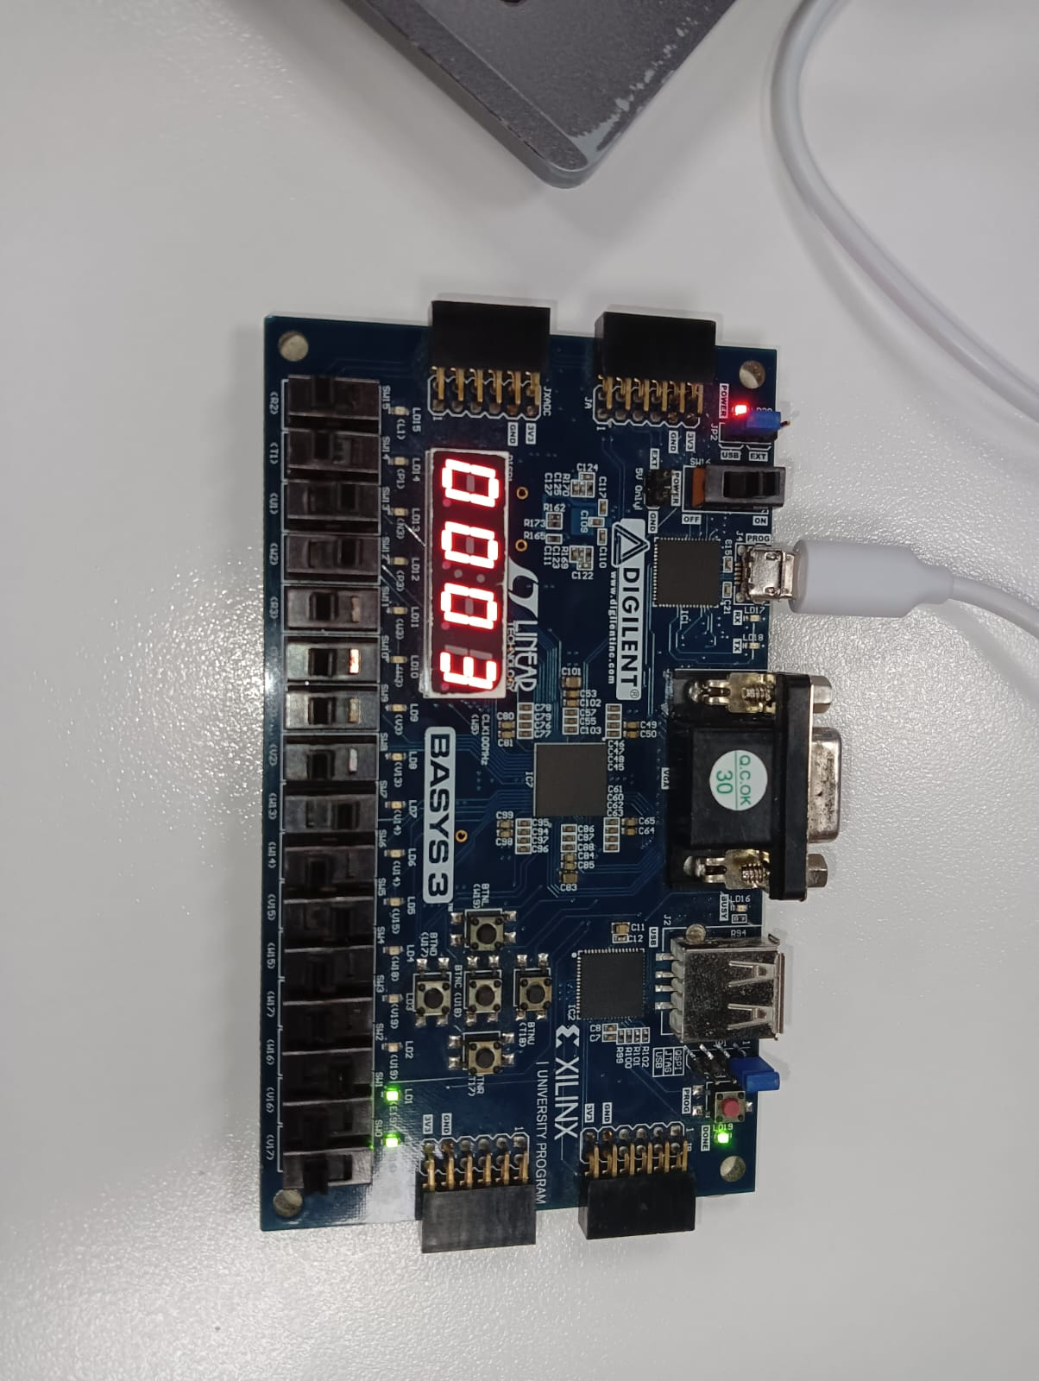

Switches[4:1] = A = 0010= 2

Switches[8:5] = B = 0101

Switches[15:11] = ALU= 0110

A-B= 3

The Video of FPGA implementation has been uploaded on TEAMS

GITHUB links:
https://github.com/Fakhariqblal/caLAB_git_si11091-main
https://github.com/MohammadNaqvi1098/CALabs-Git-mn11062.git

Assessment Rubrics

Lab 7: Design and FPGA Implementation of the Register File for a Single-Cycle RISC-V Processor

Points Distribution
Task No. | LR2  Code | LR 5  Results | LR11  Design | AR7
Task 1 | - | - | /10 | /20
Task 2 | /20 | /10 |  | /20
Task 3 | /20 | /20 |  | /20
Total Points | /80 |  |  | /20
CLO Mapped | CLO 1
For description of different levels of the mapped rubrics, please refer the provided Lab Evaluation Assessment Rubrics and Affective Domain Assessment Rubrics.
# | Assessment Elements | Level 1: Unsatisfactory  Points 0-1 | Level 2: Developing  Points 2 | Level 3:Good  Points 3 | Level 4:Exemplary  Points 4
LR2 | Program/Code/ Simulation Model/ Network Model | Program/code/simulation model/network model does not implement the required functionality and has several errors. The student is not able to utilize even the basic tools of the software. | Program/code/simulation model/network model has some errors and does not produce completely accurate results. Student has limited command on the basic tools of the software. | Program/code/simulation model/network model gives correct output but not efficiently implemented or implemented by computationally complex routine. | Program/code/simulation /network model is efficiently implemented and gives correct output. Student has full command on the basic tools of the software.
LR5 | Results & Plots | Figures/ graphs / tables are not developed or are poorly constructed with erroneous results. Titles, captions, units are not mentioned. Data is presented in an obscure manner. | Figures, graphs and tables are drawn but contain errors. Titles, captions, units are not accurate. Data presentation is not too clear. | All figures, graphs, tables are correctly drawn but contain minor errors or some of the details are missing. | Figures / graphs / tables are correctly drawn and appropriate titles/captions and proper units are mentioned. Data presentation is systematic.
AR9 | Report | All the in-lab tasks are not included in report and / or the report is submitted too late. | Most of the tasks are included in report but are not well explained. All the necessary figures / plots are not included. Report is submitted after due date. | Good summary of most the in-lab tasks is included in report. The work is supported by figures and plots with explanations. The report is submitted timely. | Detailed summary of the in-lab tasks is provided. All tasks are included and explained well. Data is presented clearly including all the necessary figures, plots and tables.

